1.Find the IP address of your computer or mobile device and write down whether it is IPv4 or IPv6. Also mention if it is a public or private IP.
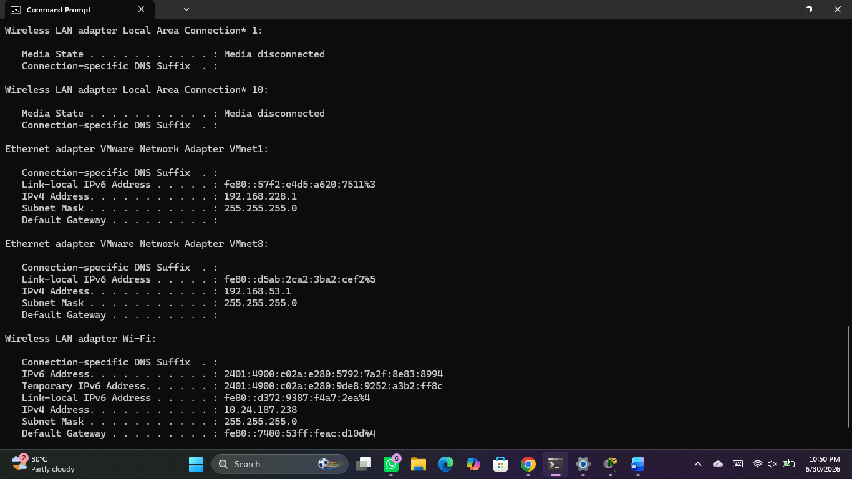
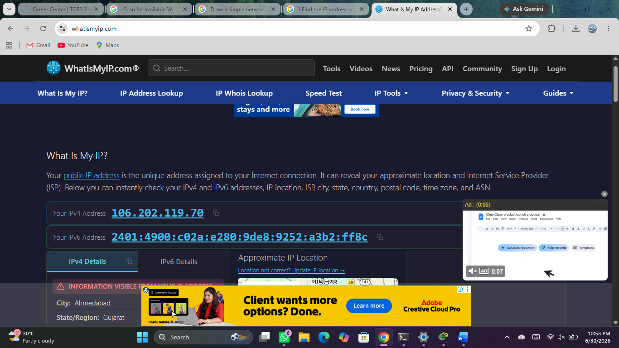
2.Given the following list of IP addresses, identify which ones are valid private IPs and which are public: 192.168.1.10, 10.0.0.5, 172.16.5.20, 8.8.8.8, 123.45.67.89. <br><br><em><strong>Hint:</strong> Check the standard private IP address ranges for IPv4.</em>
- Class A: 10.0.0.0 to 10.255.255.255
- Class B: 172.16.0.0 to 172.31.255.255
- Class C: 192.168.0.0 to 192.168.255.255
Classification Table
IP Address [8, 9, 10, 11, 12] | Type | Reason / Range Details
192.168.1.10 | Private | Falls inside the Class C private range (192.168.x.x).
10.0.0.5 | Private | Falls inside the Class A private range (10.x.x.x).
172.16.5.20 | Private | Falls inside the Class B private range (172.16.x.x through 172.31.x.x).
8.8.8.8 | Public | Outside private ranges (Google's public DNS server).
123.45.67.89 | Public | Outside private ranges (Routable on the global internet).

3.Write a short script in Python or JavaScript that takes an IP address as input and tells the user whether it is a valid IPv4 address or not. <br><br><em><strong>Constraint:</strong> Do not use any third-party libraries for validation.</em>
def is_valid_ipv4(ip_str):
# Split the string by the dot character
parts = ip_str.split('.')

# An IPv4 address must have exactly 4 octets
if len(parts) != 4:
return False

for part in parts:
# Check if the part is numeric and not empty
if not part.isdigit():
return False

# Convert to integer to check the range
num = int(part)
if num < 0 or num > 255:
return False

# Prevent leading zeros (e.g., "192.168.01.1" is invalid)
if len(part) > 1 and part[0] == '0':
return False

return True

# Example usage:
user_input = input("Enter an IP address: ")
if is_valid_ipv4(user_input):
print(f"'{user_input' is a VALID IPv4 address.")
else:
print(f"'{user_input}' is an INVALID IPv4 address.")
4.Explain with an example how Instagram or WhatsApp might use IP addresses to detect suspicious login activity from different locations.
Apps like Instagram and WhatsApp use IP addresses as digital context clues to verify your identity and block hackers. Every internet-connected device has a unique IP address that reveals its general physical location, such as the city and country.
Here is how these platforms use that data to detect suspicious activity:
The Detection Process
- Baseline Tracking: The app records your usual IP addresses, locations, and device types when you log in.
- Geographic Comparison: When a new login request occurs, the system compares the new IP location against your historical data.
- Velocity Checking: The system calculates the physical distance and time elapsed between your last active session and the new login attempt.
A Practical Example
Imagine you live in Mumbai, India, and you check your Instagram feed at 9:00 AM from your home Wi-Fi network.
- The Normal Log: Instagram logs your session with a Mumbai-based IP address.
- The Suspicious Event: At 9:15 AM (just 15 minutes later), someone attempts to log into your account using an IP address located in London, UK.
- The Trigger: Instagram's security system instantly recognizes that it is physically impossible for a human to travel from Mumbai to London in 15 minutes. This is called an impossible travel flag.
The Security Response
Because the IP address location creates a logical impossibility, the app takes immediate protective action:
- Blocking access: The system automatically freezes the suspicious login attempt from London.
- Verification challenge: The app logs out the London user and demands a Two-Factor Authentication (2FA) code or an email confirmation.
- User alert: You receive an instant notification or email saying, "We detected a suspicious login attempt from London, UK. Was this you?"

